QUESTION BANK SOLUTION
Unit 1 Introduction to Finite Automata

Obtain DFAs to accept strings of 0’s and 1’s having exactly one 0.
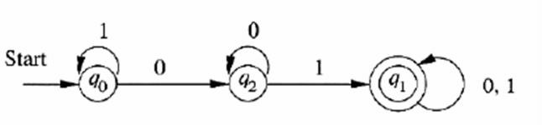

Obtain a DFA to accept strings of a’s and b’s having even number of a’s and b’s.
L = {Œ,aabb,abab,baba,baab,bbaa,aabbaa, }

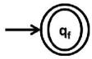
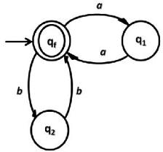
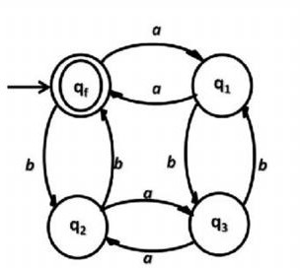

Give Applications of Finite Automata.

String Processing
Consider ﬁnding all occurrences of a short string (pattern string) within a long string (text string).
This can be done by processing the text through a DFA: the DFA for all strings that end with the pattern string. Each time the accept state is reached, the current position in the text is output.

Finite-State Machines
A ﬁnite-state machine is an FA together with actions on the arcs.

Statecharts
Statecharts model tasks as a set of states and actions. They extend FA diagrams.

Lexical Analysis

In compiling a program, the ﬁrst step is lexical analysis. This isolates keywords, identiﬁers etc., while eliminating irrelevant symbols. A token is a category, for example “identiﬁer”, “relation operator” or speciﬁc keyword.

Define DFA, NFA & Language?

Deterministic finite automaton (DFA)—also known as deterministic finite state machine—is a finite state machine that accepts/rejects finite strings of symbols and only produces a unique computation (or run) of the automaton for each input string. 'Deterministic' refers to the uniqueness of the computation. Nondeterministic finite automaton (NFA) or nondeterministic finite state machine is a finite state machine where from each state and a given input symbol the automaton may jump into several possible next states. This distinguishes it from the deterministic finite automaton (DFA), where the next possible state is uniquely determined. Although the DFA and NFA have distinct definitions, a NFA can be translated to equivalent DFA using the subset construction algorithm
A language is any subset of

Languages:
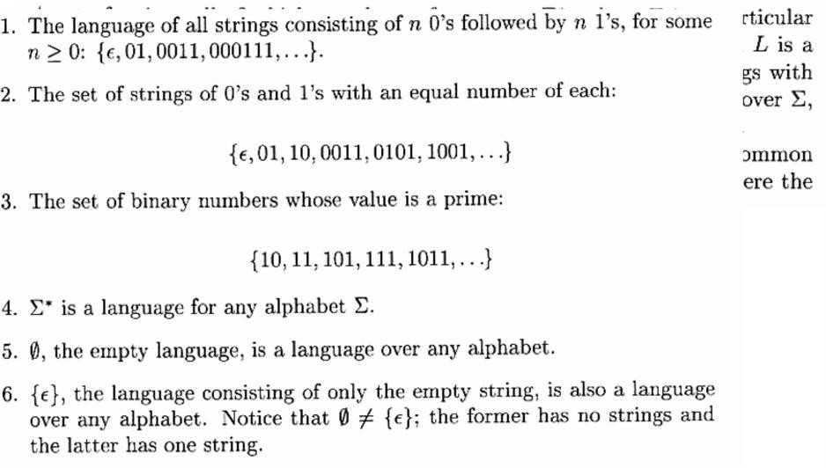

Obtain a DFA to accept strings of a’s and b’s starting with the string ab.

L = {ab,aba,abb,abab,abaa,abbb,abba }

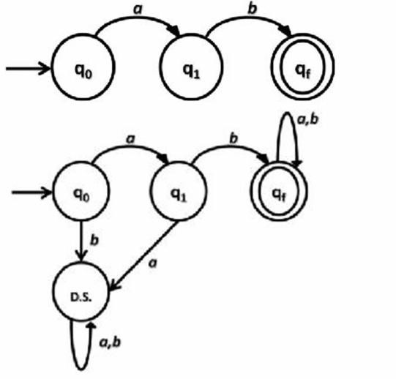

Draw a DFA to accept string of 0’s and 1’s ending with the string 011.

L= {011, 0011, 1011, 00011, 01011, 10011, 11011, },

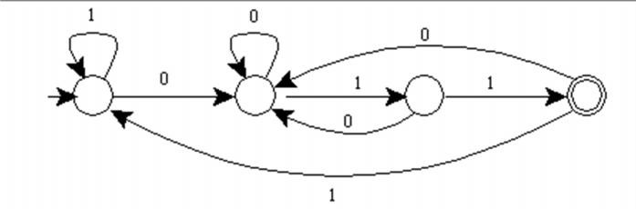

Write DFA to accept strings of 0’s, 1’s & 2’s beginning with a 0 followed by odd number of 1’s
and ending with a 2.

Design a DFA to accept string of 0’s & 1’s when interpreted as binary numbers would be
multiple of 3.

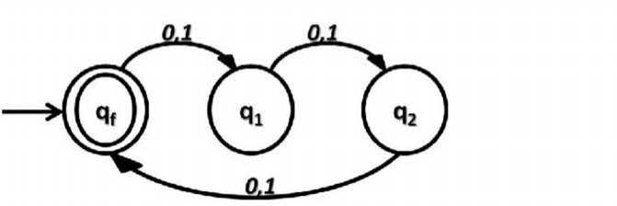

Find closure of each state and give the set of all strings of length 3 or less accepted by automaton.

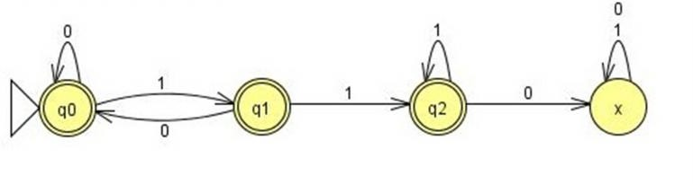
- Obtain a DFA to accept strings of a’s and b’s having a sub string aa.

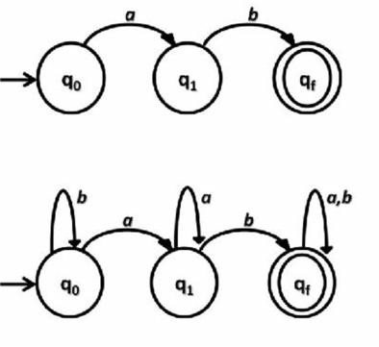

δ | 0 | 1
→  p q  * | {p,r} | {q}
→  p q  * | {r,s} | {p}
→  p q  * | {p,s}  {q,r} | {r} I

Convert above automaton to a DFA.

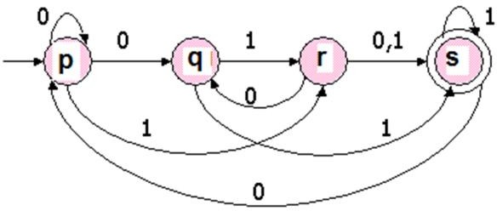

- Convert following NFA to DFA using subset construction method.

δ |  | a | b
→  p q | {r}  I | {q}  {p} | {p, r}
→  p q | {p,q} | {r} | I
→  p q |  |  | {p

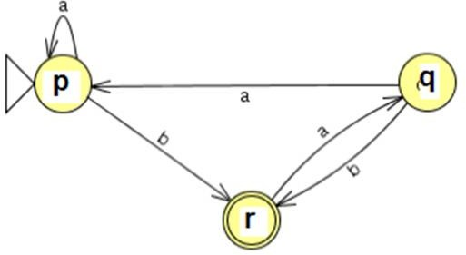

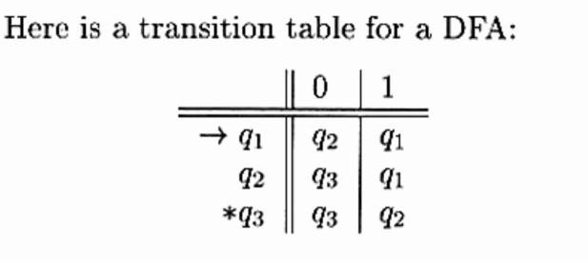

- Define NFA. With example explain the extended transition function

As with a DFA, we can de¯ ne the extended transition function of an NFA. If the transition function is ±, we usually denote the extended transition function by ^±. The basis is that ^±(q; a) := fqg:
For the induction step, let S be ^±(q; x). Then ^±(p; xa) := [p2S ±(p; a):

The Subset Construction

In order to show that DFAs and NFAs have the same computational power, gave the subset construction, which, given an NFA, constructs a DFA that accepts the same language.The alphabet of the new DFA is the same as that of the NFA. If Q is the set of states of the given NFA, then the set Q0 of states of the new DFA is P(Q), the power set of Q, that is, the set of all subsets of Q. In another words, a state of the new DFA is a set of states of the NFA.If q0 is the start state of the NFA, then fq0g is the start state of the new DFA. A state in the new DFA is accepting if it contains an accepting state of the NFA. If ± is the transition function of the NFA, then we de¯ ne the transition function ±0 of the new DFA as follows. Where S is a subset of Q and a is a symbol: ± 0 (S; a) := [ p2S ±(p; a):

- Explain the ground rules of finite automata.
- Convert the following NFA into an equivalent DFA.

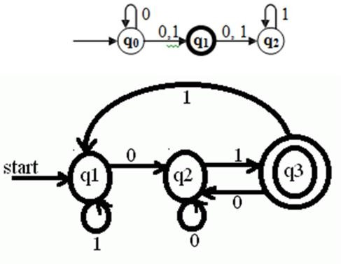

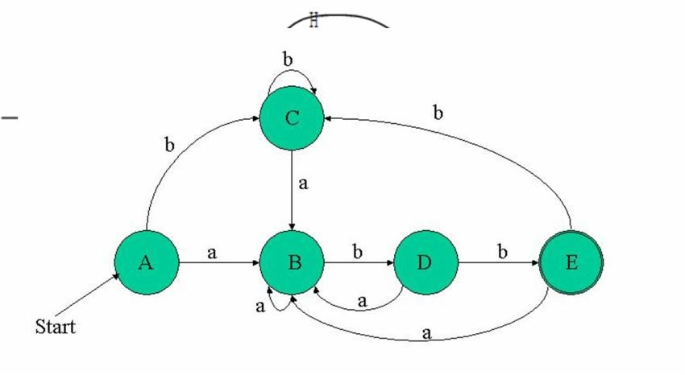

- Obtain an NFA which accepts strings of a’s and b’s starting with the string ab.
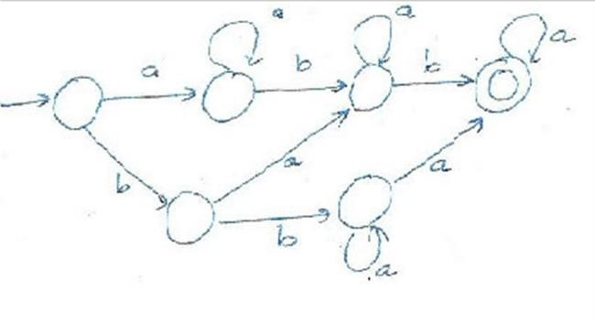

Explain finite automata with epsilon transition.
An informal treatment of €-NFA's, using transition diagrams with f allowed as a label. In the examples to follow, think of the automaton as accepting those sequences of labels along paths from the start state to an accepting state. However, each e along a path is "invisible" j i.e., it contributes nothing to the string along the path.
In Fig. is an €-NFAthat a.ccepts decimal numbers con• sisting of:2. A string of digits,
1. An optional + or - sign,
- A decimal point, and
- Another string of digits. Either this string of digits, or the string (2) can be empty, but at least one of the two strings of digits must be nonempty.
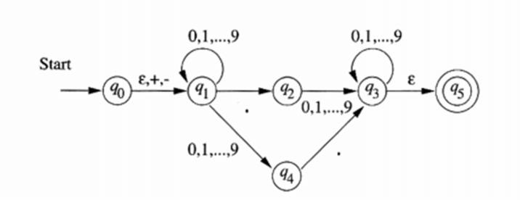

- Obtain a DFA to accept strings of a’s and b’s starting with the string ab

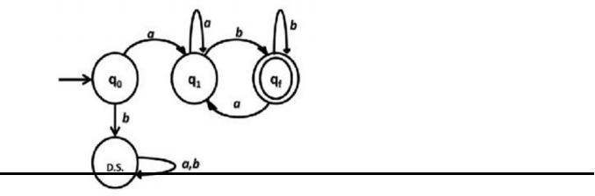

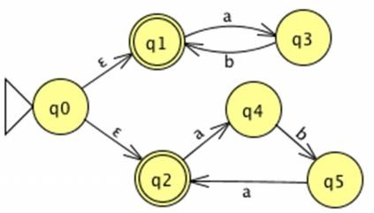
- Obtain an NFA to accept the following language L = {w | w abab^{n} or aba^{n} where n t 0}

